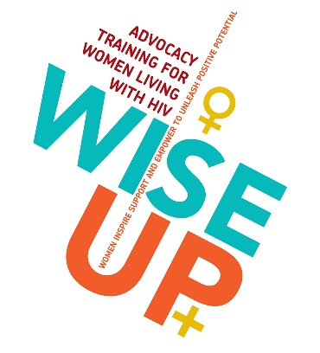

WISE UP+ Ageing with HIV – application form

WISE-UP+: WOMEN INSPIRE SUPPORT AND EMPOWER TO UNLEASH POSITIVE POTENTIAL
WISE-UP+ is a structured series of workshops designed and led by women living with HIV with the aim of building a dynamic community of female HIV advocates.
The objectives of the WISE-UP+ programmes are:
- to alleviate isolation - where there is no/low access to services, addressing unmet needs in service design and delivery;
- to increase knowledge and power – so that women are involved in healthcare decision making, dialogue with health professionals, becoming activists;
- to meet the needs of ALL HIV+ women - exploring health disparities specific to culture, age, marginalised groups and intersectionality;
- to provide a safe space where women can share experiences, be creative and develop advocacy messages to inform policy and commissioning decisions;
- to endorse positive sex messages so that women can work towards the lives and relationships they want.
WISE UP+ Ageing with HIV is a weekend retreat for women aged 45 and over who are living with HIV. Sessions will include: recent research updates on ageing with HIV; managing menopause, co-morbidities and HIV; mental health and wellbeing; addressing loneliness and isolation; developing an advocacy agenda for older women living with HIV; priorities for setting up a support group for women in the menopause; co-developing patient and clinician resources on HIV and menopause.
The retreat will be held in King’s Cross, London, starting at 5pm on Friday 4th October and closing at 5.30pm on Sunday 6th October. To ensure everyone can be actively involved in the programme, participants are required to attend the whole weekend. Travel and hotel will be provided for women attending who do not live in London, local travel will be supported for London-based participants.
Please complete the application form fully, and return to: info@sophiaforum.net. Please also get in touch at that email address if you have any questions. All applications must be received by Monday 2nd September. We will then review applications and get in touch to confirm if you have a place.
Full name
Phone number
Email address
We will communicate with you by email, unless you indicate a different preference | [Delete as appropriate]  I am happy with email  I prefer to be contacted by ….
Age
Have you previously attended a WISE UP+ workshop? If yes, please let us know which workshops (title and/or dates) | [Delete as appropriate]  Yes – please specify:  No
Why do you want to join this workshop? What do you hope to gain from it? Please provide a short (max. 200 word) statement

Do you have any dietary requirements? | [Delete as appropriate]  Yes – please specify:  No
Do you have any access requirements? | [Delete as appropriate]  Yes – please specify:  No
Anything else you think we need to know to support your participation?
What town/city will you be travelling from and returning to? Please let us know if you are based outside London but will be in London already for the BHIVA conference.

Please note: if you live in London, we will not provide accommodation, but will reimburse local travel. A valid ticket or receipt will be required for reimbursement.
If you live outside London, travel and accommodation will be provided.
We will provide training, mentoring and support for two participants to co-facilitate the workshop. This is an opportunity to gain skills and experience, and we will also provide a stipend to thank you for your support.

If you would be interested in co-facilitating, please provide a statement (max. 200 words) outlining why you would like to co-facilitate and how you think you would benefit from the training and experience.

Note, in order to take this role, you must attend a training from 5pm to 7pm on Friday 4th October.

